Dear Parents,
As a part of our review of Safety in the Science Lab and the correct use of lab equipment, students may choose one of the following projects to complete in class.
_____ Safety Apron - I would like Mrs. Gulbrandsen to order me a “Science Making Connections” apron (like below) so I can personalize and customize it to wear on lab days. Attached is my $6 to cover the cost of the apron, which will be mine to take home at the end of the year. We will be working on this as our first project in lab.
_________ I will supply my own plain white appron
Before 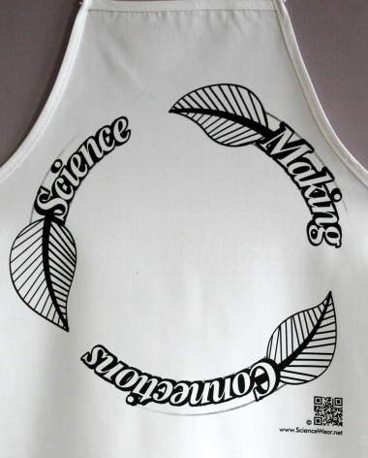 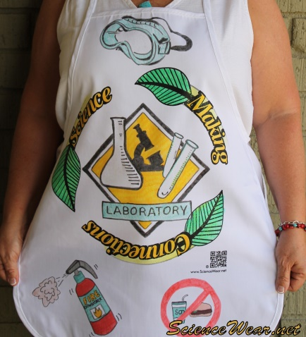 After
_____ Safety Poster - I will create an amazing safety poster with a catchy title like: “Doing Science Safely – The I.M.S. Way”. I will bring my artistic rendering (sketch) of my idea and Mrs.Gulbrandsen will supply me with miscellaneous materials to carry out the project such as glue, scissors, tape, construction paper, and NOT the poster board.
Example posters 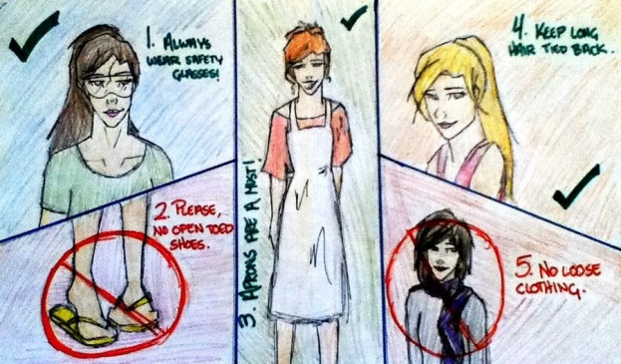 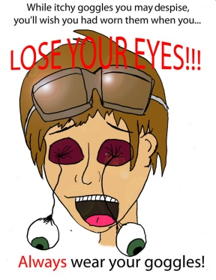
Thank you for your support of our project.

I am aware of the Safety project to be completed during science class.
Student’s name and period: _________________________ Parent signature: ____________________________
Return to science class on or before Oct 5th

